“Tech Question and Answer”

By

Mandeep Singh

Level-6

Final Project

Table of Contents

Project Proposal 3

Goals and Objectives 3

Project Scope 3

Project Specifications 3

Target Audience 3

Project Deliverables 4

Resource Requirements 4

Project Tasks and Milestones 4

Project Assumptions 5

Project Report 5

Detail Design 6

Home Page 6

Login Page 6

Flight Admin Registration Page 7

Flights Admin View 7

Passenger Page Admin View 8

Flight Bookings Page Admin View 8

Flights Page Passenger View 8

Flight Booking Page Passenger View 9

Passenger Signup Page 9

Project Testing 10

User Manual 10

Summary 11

System Configuration 11

User Access Levels 11

# 

# Project Proposal

## Goals and Objectives

Tech Question and answer is an application implemented using Asp.net. With the help of this application one can ask any tech-related questions to the experts. The good thing about this forum is that anyone can signup for it and register as a member. Once they register, they can ask any questions related to IT. In this application various users have various rights. For example- every user has admin rights to their accounts while they can only read the details of other members accounts. Member can add a new question to ask, edit, delete, and access details of the questions which they added earlier. One member cannot edit other members questions, he/she can only access the questions. These rights are similar for members accounts as well.

## Project Scope

Tech Question and Answer is an online web project of 20 days. The scope of this project is to help people to ask and find answers to any tech-related questions.

## Project Specifications

* Login by members.
* Add, edit, delete, and check details of questions by the account holder.
* New member signup.
* Existing members can manage their accounts and only view details of other user’s accounts.

## Target Audience

The audience for this project is the people who are keen to know more about tech. The age can be from 18 years to maximum can go 100 plus or more.

## 

## Project Deliverables

The deliverables of the project are:

|  |  |
| --- | --- |
| **Deliverable** | **Description** |
| Final Report | This is the final report |
| Coding | The coding will go into this. The executable code of the project. |
| Documentation | This depicts the documentation of the project. |
| Testing | All the test details will be covered in this part. |

## Resource Requirements

The technologies used in this project are as follows:

* Asp.net MVC Framework.
* Microsoft Word and excel for documentation.
* 64-bit processor and 4 GB or more RAM.
* Identity framework- ASP.
* Windows Operating System.

## Project Tasks and Milestones

The table below shows the Project Tasks and Milestones

|  |  |
| --- | --- |
| **Tasks** | **Weeks** |
| Research and analysis | 1-2 |
| Planning and first kick off meeting Project Proposal document. | 1-2 |
| Design of Database | 2-3 |
| UI design | 2-3 |
| Identity framework implementation | 2-3 |
| Coding for admin and reporter | 3-4 |
| Testing | 3-4 |
| Final Documentation | 3-4 |

## Project Assumptions

While doing the implementation, the following are the assumption made:

* Two users will be registered for the application by default.
* Every user has admin rights for their account.

# Project Report

#### Functional and Non-Functional

The functional requirements and non-functional requirements of this project are as follows:

|  |  |
| --- | --- |
| Users | Functional |
| User-1 and 2 | * Login/Logout. * New users can sign-up. * Edit, delete and check details of the questions which they asked * Edit, delete, and access details of their accounts. * Access details of questions asked by others * View details of other members |
| Non- Functional | | |
| * The project will be compatible with all browsers and devices. * Security * Fast load time of the project. * High performance * Limited access for the reporters. | | |

## Detail Design

### Home Page

This page is the main landing page of the application. On this page on the navigation menu there are options- Home, Questions, members, forum user sign-up, and login. Moreover, a button view question is also present in the header images, which when clicked shows the available questions.

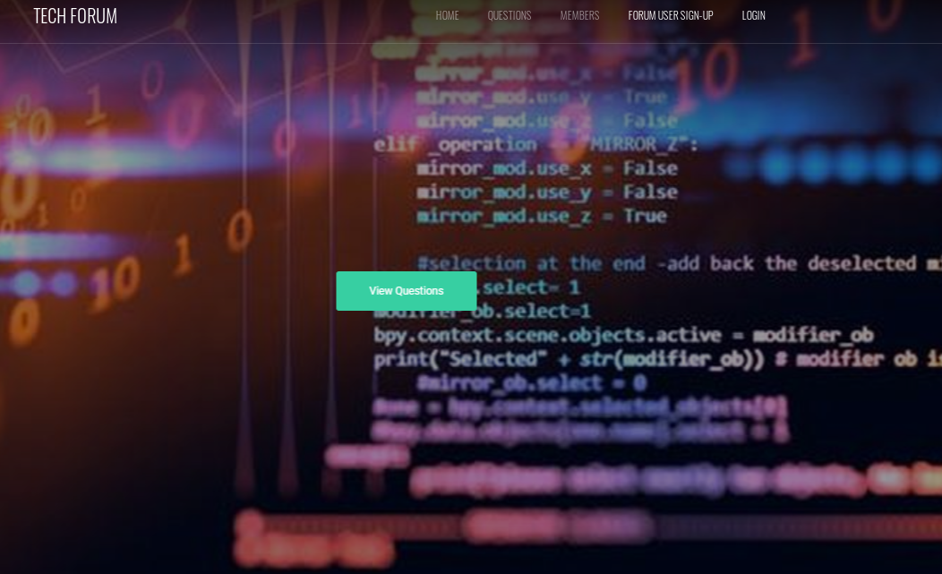

### Login Page

Using this page registered users can login to the application with the help of their valid credentials.  
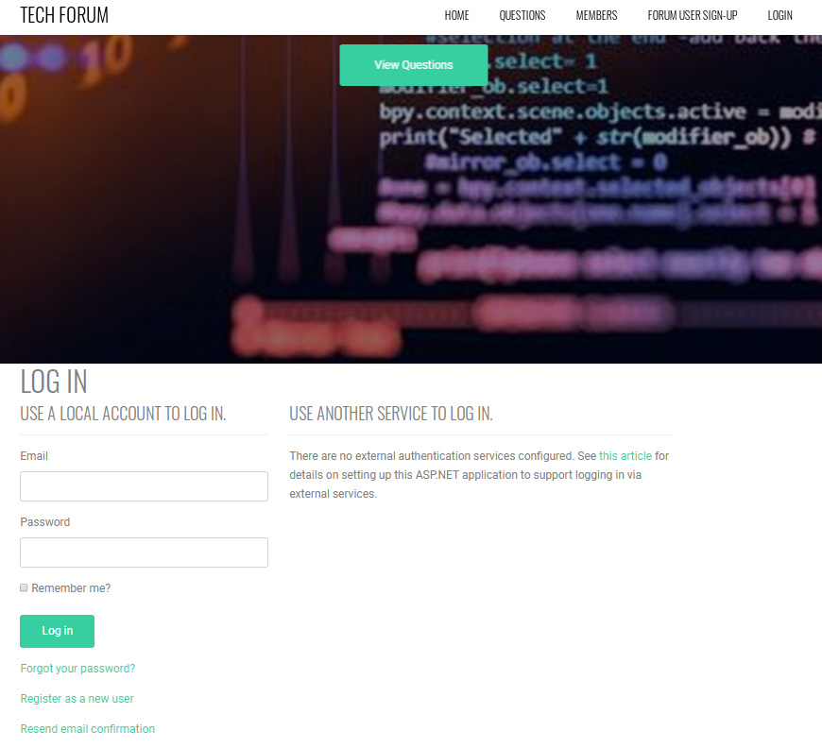

### Forum User Sign-up Page

With the help of this page, new forum users can register for the application.

### 

### Member Page

With the help of this page users can edit, delete, and view details of their accounts. One can have admin right on their accounts.

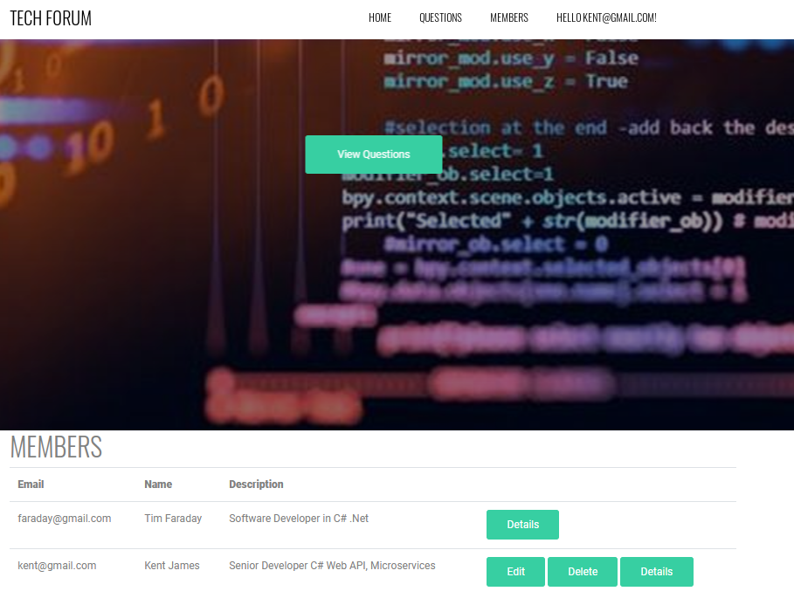

### Questions Page

With the help of this page, members can add new questions, edit, delete, and access the existing ones for their account, and for other registered users they can only view the questions.

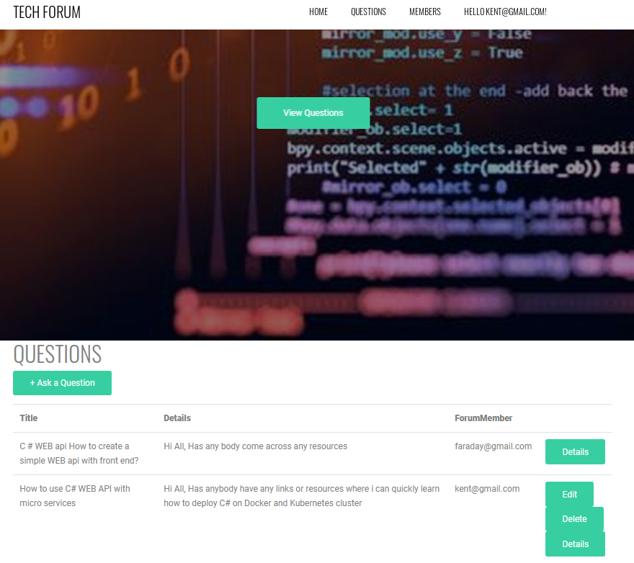

## Project Testing

Excel File Attached for Usability Testing [Tech Question and Answer.xlsx](Tech%20Question%20and%20Answer.xlsx)

# User Manual

Tech Question and answer is an application implemented using Asp.net. With the help of this application one can ask any tech-related questions to the experts. The good thing about this forum is that anyone can sign-up for it and register as a member. Once they register, they can ask any questions related to IT. In this application various users have various rights. For example- every user has admin rights to their accounts while they can only read the details of other members accounts. Member can add a new question to ask, edit, delete, and access details of the questions which they added earlier. One member cannot edit other members questions, he/she can only access the questions. These rights are similar for members accounts as well.

## Summary

### System Configuration

Tech Question and Answer app will be useful to find answers to tech-related questions.

### User Access Levels

Only registered users can access the features of Tech Question and Answer application

* Users have admin rights to their accounts and can view details of questions asked by other members.